Dynamic Clusters in Weblogic

Expand Clusters

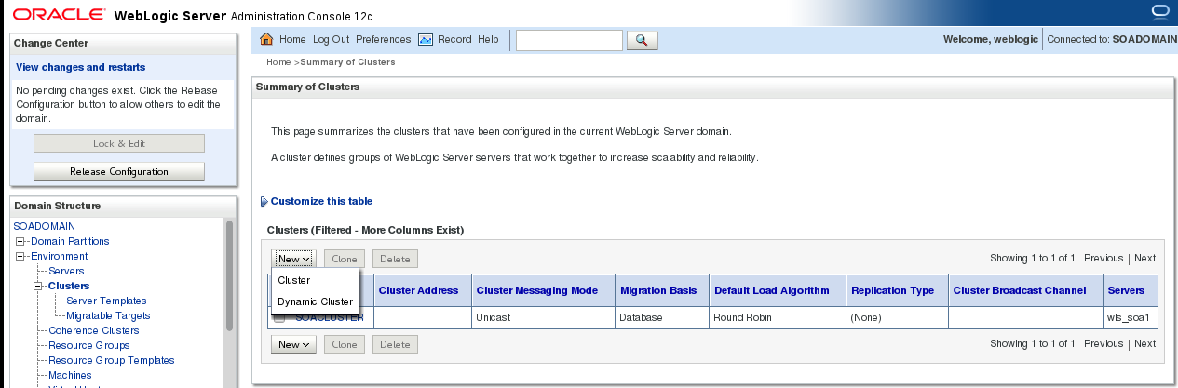

Click New and give Cluster name details

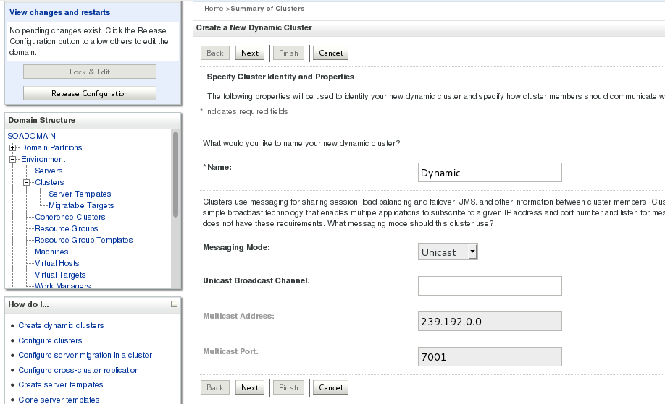

Dynamic Cluster Min And Max Size

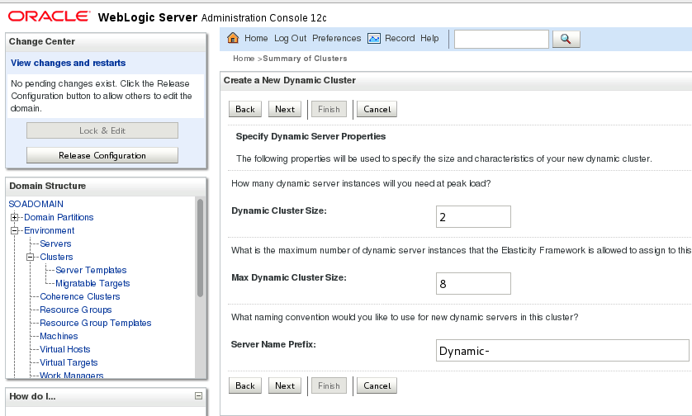

Machine details

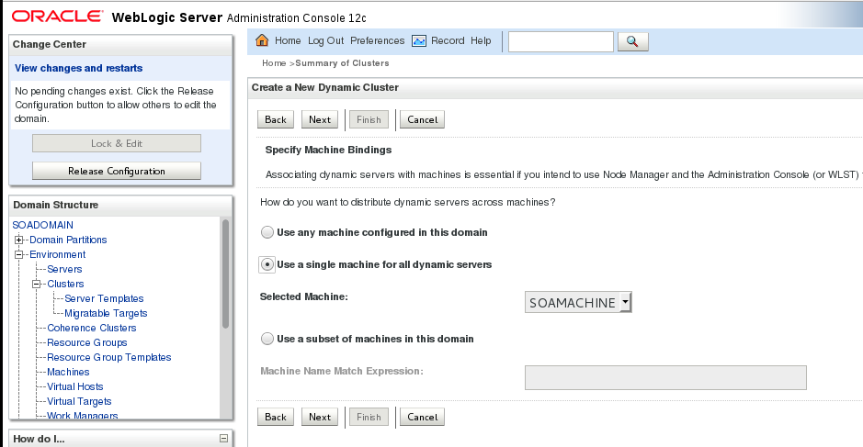

Port Details

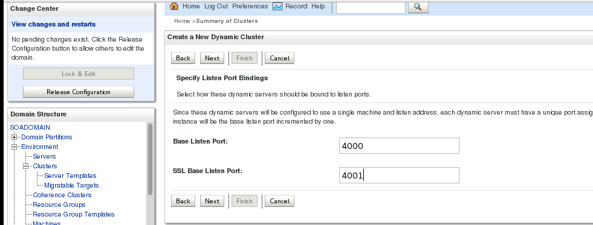

Summary

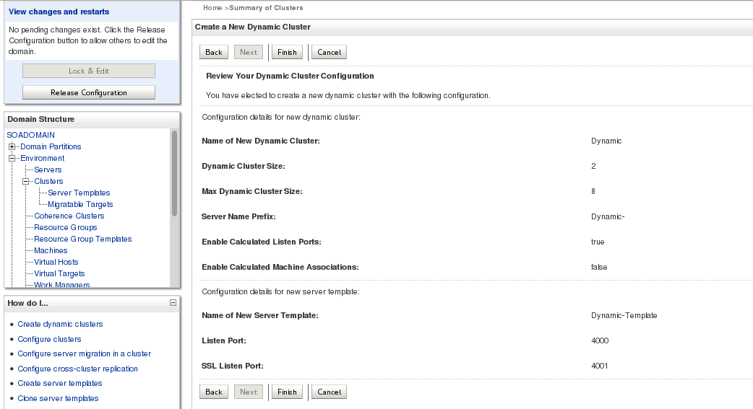

Dynamically now 2 servers were added to the cluster

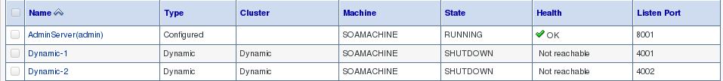

Server Template details

